”Campaign for Humanity”
Training course on dealing with cultural and religious differences and developing local online and offline campaigning against xenophobia and racism
08 - 15 October 2017, Szeged, Hungary

Themes of the training course:

After the Arabic Spring lot of countries lost their stability in Asia and Northern Africa. Also climate change causing the lack of clean water and land to cultivate, a huge number of migrants started their exodus from these areas for a better life or to save their lives. Countries on the border of the EU, and generally all of them are facing a huge immigration pressure from people arriving with very different cultural and religious background.
We, as international youth workers are shocked by some of the states’ responses, since it is totally against the European values. As those working with intercultural learning, acceptance of other cultures, solidarity, support of cultural diversity, as individuals, already started to help volunteering groups helping refugees and immigrants to be able to live with their rights given by international law. This made us to start thinking how we could use and offer our capacities to this problem; that with our knowledge, partnerships and resources how we could help fighting fears, ignorance of the situation or growing racism – in some cases even encouraged by governments – in this very quickly changing demographical situation in Europe.
The needs, fears we would like to reflect to in our project:
- Biggest immigration pressure on Europe in modern times;
- No exact and general solution plans from EU countries, since the phenomenon is very quickly escalating. It even causes tension between the EU countries;
- Growing fears of local population, even encouraged by political forces;
- Growing racism and radicalisation;
We selected these topics, because our main idea was that we have to reflect on what is happening at the moment, since we cannot avoid being involved in these happenings, because of our previous work, our values and principles. We have the potential background to contribute to the solution on our level.
We strongly believe that people need to know the facts about immigration in order to have a clear picture regarding to the current immigration situation, understand the reality of the immigrants, explore the truth behind political communication, discover the human behind the crisis and explore the possibilities for giving support and cooperate together for the peace of Europe and for the peace of people who survived wars. Fear is a power, nevertheless Love is a power, we would like to give the chance to choose between them based on information and campaigning offline and online against xenophobia and racisms towards immigrants/refugees/human beings.

The overall aim of the training course is to fight against xenophobia and arising racism towards immigrants, to change the negative feelings regarding to migration into positive approach based on understanding of the backgrounds of immigrants and the political and cultural based roots of fears and ignorance of the societies. To train youth workers, youth leaders how to invent offline and online campaigns with, for and by young people in order to support the integration of young people with immigrants’ background and fight for humanity and European values.

Learning objectives of the training course are:
- To raise awareness on the reasons of ignoring, generating fears from immigrants, and becoming racists connected to immigration in the EU;
- To gain experiences on developing and improving methods, tools and techniques in order to discover and accept cultural and religious diversity;
- To clarify and define the meaning of stereotypes, prejudices and discrimination based on human rights education related with migration;
- To enable young people, youth workers, teachers, social workers, psychologists, for recognising prejudgements, prejudices towards immigrants;
- To identify and define the roots and origins of xenophobia and racism;
- To develop critical way of thinking;
- To ensure different ways of active participation of young people within local and international youth campaign against xenophobia and racism;
- To raise awareness on universal human rights of immigrants; to fight against xenophobia and racism towards immigrants and to develop intercultural sensitiveness through web 2.0 as social media tools and through offline tools as street campaigning by street theatre, peer education, posters, flyers, humanitarian aid actions as supporting immigrants, etc.

The methodology of the training course:
The project is based on the methodology of non – formal education; it will be voluntary based and learner – centred. Experienced international trainers’ team will conduct all methods based on the needs and expectations of the partner organisations and the participants. In the preparation phase local research in the participated countries will be run about the reasons of ignoring, generating fears from immigrants, and becoming racists connected to immigration. The results will support youth workers, teachers and young people to understand their feelings and reactions and where these perceptions come from. This understanding can help to fight against xenophobia and racism and can be used as a fundamental base of campaigns. Campaign booklet against xenophobia and racism, including correct information about the reasons of immigration, the immigrating groups and their cultural and religious backgrounds: during the project local campaigns will be run by young people with the support of youth workers, teachers, social workers, psychologist, etc. These campaigns will happen in online and offline forms and addressing all parts
of societies in order to spread the true facts from immigrants instead of lies and find more humanitarian aids for people in need. The planned programme flow:
- Getting to know each other and the partner organisations;
- Me and the immigrants: culture and cultural diversity;
- My society and the immigrants: Universal declaration of human rights, stereotypes, prejudices, xenophobia and racism;
- Campaigning in theory: target group and message, communicational channels;
- Offline campaign in practice: running a local campaign against xenophobia and racism towards immigrants;
- Online campaign in practice: running online campaigns against xenophobia and racism towards immigrants;
- Preparing local offline and online campaign by the participated organisations in their local communities with, for and by young people against xenophobia and racism towards immigrants;
- Cooperation agreement for supporting each others’ campaigns back to the reality;
- Erasmus + as a tool for further cooperation and fighting for humanity.
Theoretical background:
- Universal Declaration of Human Rights;
- Definitions of xenophobia, racism, stereotypes and prejudices, etc.
- Methodology of offline and online campaigning;
- Erasmus + programme.
Practical background:
- Making offline and online campaigns against xenophobia and racism towards immigrants.
- Methods we plan to use: working in national teams, in mixed teams, individual and pair work, putting theories into practice, theatre, montage, campaigning, etc.

Who can participate in the training course:
- Aged between 18 and …
- Youth workers, youth leaders, project managers, decision makers, teachers, social workers, psychologist, etc. directly working young people in general with special focus on immigrants’ background;
- Ready to take part in the whole training course;
- Have organizational support for further activities on campaigning with immigrants young people;
- To be able to communicate English language.

Preliminary programme:
Hours | Day 1  Arrival day | Day 2  Getting 2 know | Day 3  Me and the immigrants | Day 4  Campaigning in theory | Day 5  Campaigning in practice | Day 6  Online and offline campaigning | Day 7  Future steps | Departure day
7.00 – 09.00 | Arrival of participants  Registration and accommodation | breakfast | Breakfast | Breakfast | breakfast | breakfast | breakfast | breakfast
09.30– 11.00 | Arrival of participants  Registration and accommodation | Getting to know each other | Understanding culture – what it is? –  What is cultural diversity? | What is the rationale of a youth campaign? | Street action - Let Paper Speak!  Supporting the work of MigSzol Szeged | Online communication – use your creativity against xenophobia and racism towards refugees/ immigrants | Erasmus + as a tool for humanity | Departure of participants
11.00– 11.30 | Arrival of participants  Registration and accommodation | Coffee break | Coffee break | Coffee break |  |  | Coffee break | Departure of participants
11.30– 13.00 | Arrival of participants  Registration and accommodation | Presentation of programme and aim and objectives, Youthpass | Universal Declaration of Human Rights | Precise identification of target groups - Why it is important and how we  do it?  Channels of communication and message development in youth campaigning  Discussion |  |  | Cooperation agreement as angel support for the local campaigns and European projects | Departure of participants
13.00– 15.00 |  | Lunch | Lunch | Lunch | Lunch | Lunch | Lunch | Departure of participants
15.00-16.30 | Course Opening Ceremony  Welcome by host  Welcome by trainers | Presentations of fears, expectations and contributions (FE&C)  Presentations of activities, aims, objectives and plans of organisations represented by participants | Stereotypes and prejudices – presenting the outcomes of the local researches of about the reasons of ignoring, generating fears from immigrants, and becoming racists connected to immigration | Motivation - important phase of a youth campaign! | Free afternoon | Designing local online and offline campaigns against xenophobia and racism by with and for young people  DET - Daily Evaluation Teams | Youthpass learning process | Departure of participants
16.30-17.00 | Coffee break | Coffee break | Coffee break | Coffee break | Free afternoon |  | Coffee break | Departure of participants
17.00–18.30  18.30 – 19.00 | Presentation of context of training  Introduction by participants  Introduction to the venue | Development of Intercultural sensitiveness by Milton J. Bennett model  DET - Daily Evaluation Teams | Prejudgment and reality of immigrants/refugees  Where our perceptions come from?  DET - Daily Evaluation Teams | Channels of communication and message development in youth campaigning  DET - Daily Evaluation Teams | Free afternoon |  | Evaluation of the training course | Departure of participants
19.30-20.30 | Dinner | Dinner | Dinner | Dinner | Dinner | Dinner | Dinner | Departure of participants
21.00- | Welcome reception organised by YOPA evening | Evening of Europe | Movie evening on current situation of immigration right now | Campaign exploration | Treasure hunting evening | Steam out evening | Farewell evening | Departure of participants

Some information about the venue and the project
City of Szeged
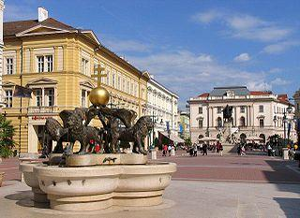
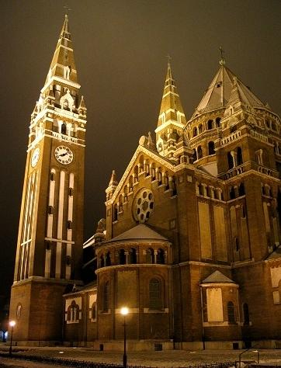
Szeged is the third largest city of Hungary, the largest city and regional centre of the Southern Great Plain and the county town of Csongrád county with its 167.000 inhabitants. It’s situated at the estuary of the River Tisza and the River Maros.
Please, visit the following website to get to know more:
http://tip.szegedvaros.hu/index.php?option=com_static&Itemid=5&lang=8859-1
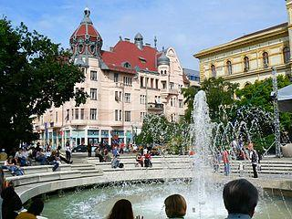
During the training course, there will be Gerilla Gourmet Festival between 13 – 15 October 2017:


https://www.facebook.com/gerillagourmet
This means food tracks, drinks, parties and Rock N’ Roll in the Széchenyi square, the main square of Szeged. This one will be about chilly and paprika and food around them☺

Accommodation and meals
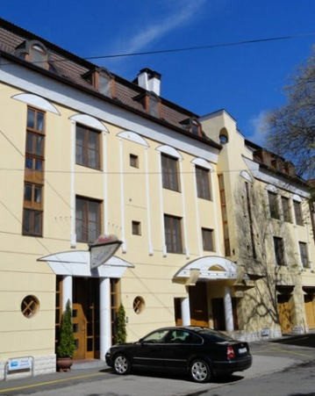
During the Training Course you will be lodged in Matrix Hotel. It has rooms with 2 – 3 beds and private bathrooms. The accommodation is located near to the city centre. The address of the accommodation: Szeged, Zárda utca 8.
Please visit http://matrixhotel.eu/en/to find more information the place. Participants will be provided with 3 meals per day (breakfast, lunch and dinner), based on different dietary needs. During sessions, we will provide 2 coffee/tea breaks per working day. All the other personal expenses participants will cover by themselves.

Our currency and prices
Our currency is Forint (HUF). 1 Euro is approximately 300-310 Forints. You will be able to exchange money at the Airport (you should change some money there because you will need Forint to buy the bus and the train tickets. I suggest you not to change a lot cause the rates are not the best at the airport. In Szeged the rates little better, and you can choose among more possibilities (banks, exchange offices). The price of the train tickets are 6790 Forint, and one single ticket in Budapest is 350 Forint, so you should change in the airport minimum 8000 - 9000 Forint.

Financial conditions:
The food and accommodation will be provided and paid by the organizers. Travels costs will be reimbursed by bank transfer after the course. It may be that money from European Commission will be late (be ready for that). The reimbursement fee will be counted according to the distance calculator of European Commission: There is 30 EUR participation fee!

The reimbursement fee will be counted according to the distance calculator of European Commission:
Country | Maximum travelling reimbursement per participant  (tickets, invoices will be needed!!!)
Portugal | € 360,00
Italy | € 275,00
Finland | € 275,00
Turkey | € 275,00
Romania | € 180,00
Spain | € 275,00
Malta | € 275,00
REGISTRATION FORM
Personal Data
The contact details you provide us below will be used for all correspondence!
First Name  [as on your passport] |  |  | Family Name  [as on your passport]
Nationality |  | Birthday with the venue (age) |  | Gender | Female  Male
Complete address
Postal code |  | Town |  | Country
Phone (preferably mobile)  [with full international dial codes] |  |  | Fax  [with full international dial codes]
Email |  |  | Website
Language(s) abilities: Please mention all languages in which you are able to work and indicate your level for each of it (B-basic, G-good, VG-very good, F-fluent, MT-mother tongue) Anyway we would like to remind you that main working language will be English.
 | Listening | Speaking | Reading | Writing
English
Other languages
[please specify]

Do you have any special needs or requirements that the host organisation should know about? (E.g. mobility, medical needs, allergies, dietary restrictions, smoker/non-smoker)

Your organisation
Name
Complete address
Postal code |  | Town |  | Country
Phone  [with full international dial codes] |  |  | Fax  [with full international dial codes]
Email |  |  | Website
Activity level | local regional national international

Please describe briefly your organisation
What are the objectives, main activities and target group of your organisation?

What are your roles (volunteer, youth worker, board member, director ...) and your tasks? Please say how long you have been involved in youth work?

Knowledge and experiences

What type of training (if any) have you followed regarding international youth work, non-formal education, Erasmus + programme, intercultural learning, cultural diversity, human rights?

What is your level of knowledge of the programmes, listed bellow?
 | Low | Medium | High
KA1 youth exchanges
KA1 European Voluntary Service
KA1 Youth workers mobility

Please, list here short movies, links in related with campaigns for refugees, migrants in international level and/or in your language!

Motivation and Expectations:

Please describe briefly your motivation to participate within this training course?

What would you like to learn, understand and experience during this training course?

What contributions can you bring for the training course?

Please indicate us the name and full contact details of a person to be contacted in case of emergency during the course
Name
Complete address
Postal code |  | Town |  | Country
Phone  [with full international dial codes] |  |  | Fax  [with full international dial codes]
Email

Please take note of the following conditions that will apply if you are selected to take part in the seminar.
- I commit myself to participate in the whole process, including:
- to prepare myself carefully for the training course and to do all remote preparation work the team will ask for,
- to take part in the full duration of the training course
- to participate in the whole evaluation process
- I understand that the information I provided on my special needs does not remove my own personal responsibility for ensuring my own health.
Signature of applicant: Date:

Supporting signatures:
I confirm my organisation/institution/Local Authority wishes to take part in transnational activities through the training course “Campaign for Humanity” and that the above-named person has the support of my organisation and has obtained full permission to be released from his/her usual duties to undertake this training course.
Name and Position (manager/senior officer/board member) of organisation’s representative:
Signature of organisation’s representative: Date:

Applications should be sent by e-mail to: yopa@yopa.hu no later than 08.09.2017.
If for any reason you are no longer able to attend the seminar, please inform us as soon as possible so that the training organisers can ensure a replacement from the waiting list.

