EVS PROJECT IN SPAIN
The Beauty of the Valley
The GDR Valle del Guadalhorce is looking for 2 EVS volunteers motivated to work with children and young people in a rural area, about rural development through non-formal educational activities.
Project title: The Beauty of the Valley.
Project dates: STARTING AS SOON AS POSSIBLE (MARCH/APRIL 2018) - Duration: 10 months.
Location: Pizarra (Málaga, Spain).

The Hosting and Coordinating Organization:
GDR VALLE DEL GUADALHORCE
The GDR of the Guadalhorce’s Valley is a non-profit association created in 1996, in an interior area of Málaga, with the aim of promoting rural development working in different areas such as Youth, Volunteering, European Mobility, Gender Equality, Organic Agriculture and Farming, because we consider that an integral development is the best way to grow.

Thus, Social Innovation applied to Local Development is our way of working, considering people like the key for solving their difficulties whether they are social, environmental and economic problems, improving quality of life and meeting real needs of our territory. In 2009, our organization was recognized like "Social Innovation Spaces" as a result of our work on methodology "button-up". Therefore our main valour is to carry out the empirical application of hypothesis or theory in the territory and with the different sector.
The GDR of the Guadalhorce’s Valley has been developing a non-stop work in the youth field, being one of the most important areas in our organization.
We really believe on the power of people in order to transform and to add value to their territory at the same time that they grow, personally and professionally. Within this area, we work in different local and international projects such as “Peer to Peer Mediation” in high schools; the promotion of different training courses; the creation of strategies for the employment (such as network meetings or local workshops related to the improvement of the skills of young people in job search) and the mobility projects within the frame of European programme, mainly ERASMUS+.
We have a really wide experience organizing youth exchanges and training courses, we are also a sending, hosting and coordinating organization for EVS, having a really good experience implementing projects about different topics through non-formal education.

The AIMS of The Beauty of the Valley
The goals of this EVS project are to dynamize our territory, increasing the opportunities for young people, their job, training and mobility opportunities but also giving value to their own resources and the possitive aspects of living in a rural area, while we open our minds to multiculturality.
The following activities are proposed to address that situation:
- To promote the active participation of young people of the territory, improving their employability, training and mobility opportunities, promoting also the relationships between people from different cultures and intercultural dialogue.
- To improve linguistic skills of scholars and young people with fewer opportunities, through activities after-school and support activities, using non-formal education methodology.
- To promote intercultural learning and language competences among children and young people from a local school, through the assitance in classes and development of workshops to share their culture and promote the learning through non-formal activities.
With all these goals, we will be working on youth dynamization with different especialities. Each of the volunteers will work with similar activities and sharing some of the tasks working in teams, but each of them will be more focussed in one of these fields (in relation with their skills) for some of the activities developed within the organization:
- Youth and Children Dynamization in the LOURDES SCHOOL. 1 person.

- Youth Work. General Activities. 1 people.
Some info about the Fields of Work that we will develop during this project...

- Youth and Children Dynamization at LOURDES SCHOOL.
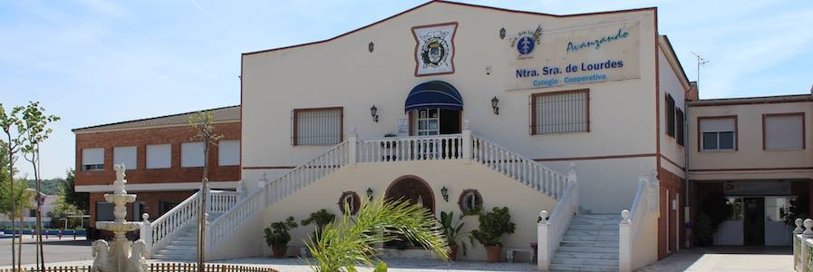

The Cooperative School Nuestra Señora de Lourdes is a cooperative institution of education located in Coín, in the region of the Guadalhorce’s Valley.
Our school has all the educative phases, from nursery, pre-primary school, primary school, secondary school/high school and bachillerato. However, our school not only has a formal education proposal but also a holistic perspective of the education, where we also integrate non-formal education and activities to promote the personal growth of our students and their improvement in key skills for their future.
In this way, we also have the necessary facilities in our center such as school center, 3 basketball courts, modern and ITC adapted classes, etc. In relation with staff and services, we have an integration class, speech therapist, physiotherapy, special education teacher, psychologist and the rest of the educative staff specialist in each subject.
Also we offer a high number of extra activities for students and also for parents, such as computer classes, yoga, sports, personal development and we have a sport club, a language class (since we are a Cambridge examination center) and music school.
Our school has been working for more than 30 years with staff especially focused in improving the communication between students/teachers and families. We care for offering the best service to our students and families and also the best education so they can feel listened, valued and part of the learning process.
Furthermore, our school is integrated in our region in the sense of cooperating with the people and associations which are part of it, such as the Rural Development Group of our region, the Guadalhorce's Valley. We are part of the Board of the entity and we also collaborate in activities proposed by them like the program for Peer to Peer Mediation, gender trainings, the pact for inclusive language or other youth activities proposed by local associations like IMAGINA, with the promotion of youth projects in the field of Erasmus + for young people of our center. http://www.colegiodelourdes.com/

The activities developed in the center would be related with:
- Promotion of mobility projects among our students in collaboration with the GDR and the 3rd field of work.
- Support to the development of linguistic skills of students. Here we will develop workshops and activities to promote expression in English, so students can talk with volunteers in non-formal activities such as chat sessions, tandem clubs, etc. Also volunteers will support English teachers as conversation assistant.
- Creativity and cultural workshops with students.
- Support to the International Committee of the Center: looking for partners, organizing European projects and activities.

Profile of Volunteer:
- Good English level (B2) will be well-valued.
- Competences on youth dynamization. Interest in working with young people and children.
- Capacity on working with paper work, being flexible.
- 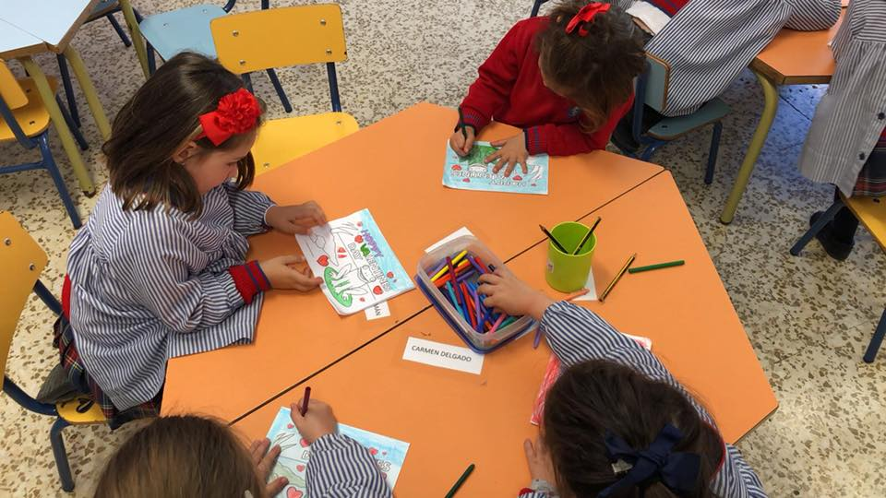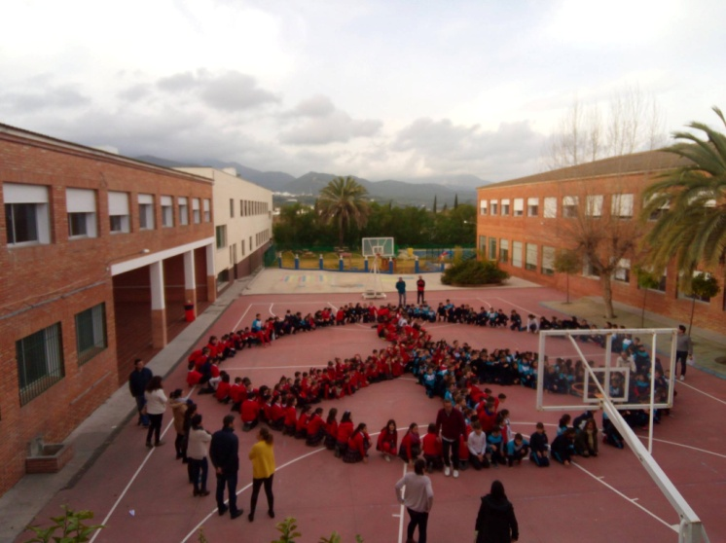Interest in teaching and educative system.

- Youth WORK at the GDR
- At the office: paperwork and MEDIA!
- Promotion of Mobility Projects abroad.
- Implementing YOUTH PROJECTS here!

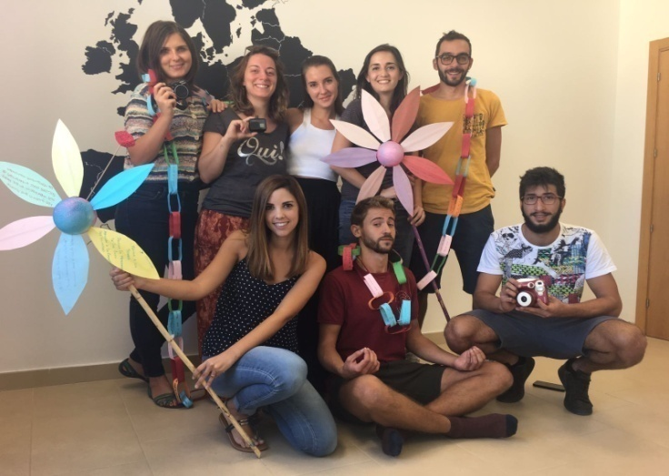

This field will be the GENERAL work in which all the volunteers of the entity will collaborate in some of the moments when we have more activities. However, one person will be more focused in this part, with different task depending on their skills and interests.
Within this common area we will develop different activities with the aim of:
- MEDIA WORK: edition of videos, photos during projects, promotion of activities in social media, etc. If you like working with MEDIA, this is your place!
- Helping the organisation with the work at the office related to organization of events, dissemination, promotion of activities, etc.
- Promoting local and international mobility projects for youngsters within Erasmus + programme.
- Preparation and training of participants who will take part in Erasmus + projects: selection process, pre-departure trainings, information, etc.
- Promotion of mobility programs such as Erasmus + and EVS: working in our local project Europe Splash, organizing workshops and dissemination activities, counselling young people, preparing them to go abroad challenging their fears...
- Support in the implementation of youth projects of our organization in our region (youth exchanges, training courses, Mediation project, etc.). These tasks will consist on: Administrative tasks (especially in the previous months to the implementation of projects like Erasmus + or Mediation); logistical tasks during the projects; organizing and support within youth exchanges and TC, etc.

Profile of Volunteer:
- Good English level (B2) will be well-valued.
- Competences on youth dynamization. Interest in working with young people and children.
- Digital Skills will be well-valued (video edition, photography, use of social networks, computer skills…).
- Interest in working with youngsters with functional diverstity: interest in learning and also some experience in the fields of occupational therapy, education or social work will be well-valued.

Some common competences very important to us are:
- Motivation to work with young people from rural areas and to be involved in our organization.
- Capacity to build a trusting relationship with the youngsters.
- Capacity to work in a team with the other volunteers and the staff or the association.
- Some experience in the Erasmus + Programme and the organization of youth projects would be valued.
- Capacity to adapt to a rural environment.
- Flexible with the work, since some of our activities will be developed during the afternoon or weekends and others will change (dates, change of local policies, etc. Affects us very much, so we need your empathy to organize the work having in mind these conditions).
- Creativity, enthusiasm, new ideas are welcomed!
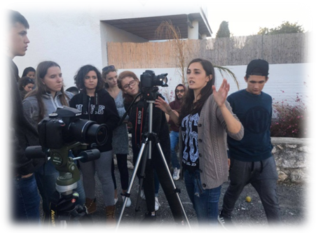

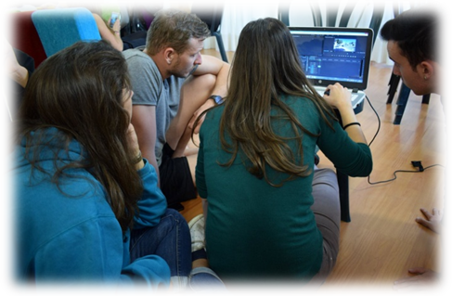

Technical Information:
Accomodation and Location:
Depending on your project, you will be living in Pizarra or Coín, two different towns located in the Province of Málaga. The volunteer working in LOURDES SCHOOL (2), will live in Coín. The other 3 volunteers will live in Pizarra.

Living in Pizarra

Volunteers will be living in rooms in a shared flat/house with other EVS volunteers. The flat information is included in the dossier of FLAT CALLE NUEVA, where you can see all the info and rules of the aparment.

The 3 volunteers working on LINGUISTIC SUPPORT (1) and YOUTH DINAMIZATION (3) will work mainly in Pizarra and Cerralba, but also some of the activities will have place in other rural towns. Our office, where we prepare and organize all the youth work is located in Cerralba, which is a hamlet with about 1.000 inhabitants, located in an isolated area of the town Pizarra (9.201 inhabitants), which is half an hour from Málaga City. You will live in Pizarra but you will come everyday to the office in Cerralba or to other neighborhood called Zalea, also nearby.
This unique situation will allow the volunteer to live in a rural lifestyle, with the benefits that we have a wonderful wheather, fresh products and quiet lifestyle, but we also count with all the facilities like shops, supermarkets, sport centers, restaurants... BUT, for the people who need to live in a city or who doesn’t tolerate the problems related to rural areas (limited means of transport and limited availability of schedules, limited modern facilities like cinema, big shoping centers, etc.), think well about this before applying!

Here you have the link of the Pizarra website with more info about the town https://www.pizarra.es/

Also, our previous volunteers have developed a platform including information of the village, how to arrive, restaurants, hostels, places to visit or activities to do! Here you have the link where you can find all this information of the web ENTER RURAL:
http://www.enterrural.com/pizarra/
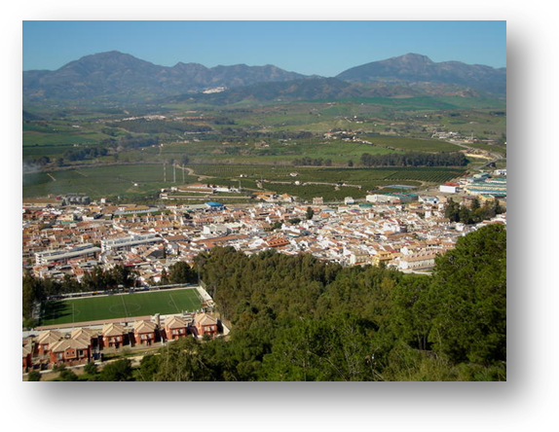

Living in Coín

If you are the lucky volunteer of the LOURDES School, you will live in Coín, a town from the province of Málaga.
Coín is a bigger town than Pizarra, with 127km2 and more than 21.000 inhabitants. It also has facilities such as shopping malls, cinema and a great cultural diversity, associations, youth movements, ...
Coín is also a rural town, very proud of its local products and organic farmers, so you will also have the opportunity to enjoy this aspect. However, if you are a person who needs to live in a big city, think about it before applying! Because you will need to be flexible with some of the needs that a rural area has: limited means of transport to go to other towns or to Málaga, for example.

The volunteer will be living in rooms in a shared flat/house with a teacher of the school. The flat information is included in the dossier of FLAT COIN, where you can see all the info and rules of the aparment.
This flat is really near from the school (2 minutes walking) and it is also near the town, you can go by foot but also you can profit of the bus of the school if you need it.

Here you can find more information about the town: http://www.coin.es/index.php?id=51

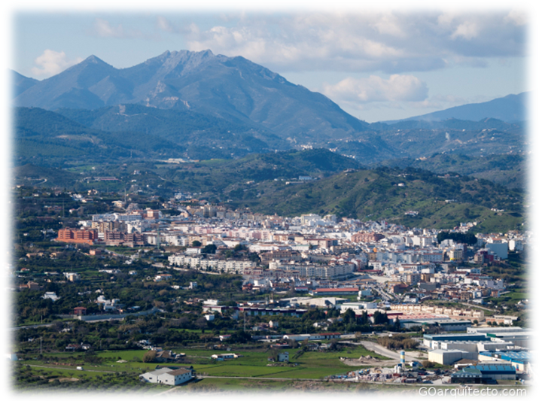

Food Allowance, Pocket Money and Transport:

- Volunteers of Pizarra will receive:
- Pocket Money: 4€/day.
- Food allowance: 150€/month.
- Transport card: to come from Pizarra to Cerralba everyday.

- Volunteer of Coín will receive:
- Pocket Money: 4€/day.
- Food allowance: 100€/month + food tickets to eat from Monday-Friday at the school cantine.

Application:
If you are a CANDIDATE FOR THIS EVS project, you can apply for one of the areas of activities described below, even though you will also be supporting your EVS-mates with their tasks (always that it doestn’t require a specific knowledge) and you will also have common tasks.
Read carefully the detailed information about each of them and find the most suitable for you.
To apply for this project, you have to fill the document PRE-SELECTION INTERVIEW, that you will find at the end of this document. In this questionnaire you have to sort, according with your preferences, the areas that you would like to be involved in.
Then, write your CV and your Cover Letter in english, saying why do you want to take part in the activity/project you chose and send them to: juventud@valledelguadalhorce.com or to your SENDING ORGANIZATION, together with the PRE-SELECTION INTERVIEW.
Then, we will contact you by email to do a Skype interview.
After that, we will also communicate the results of the selection process by email...so wait for the answer, and good luck!
Deadline for Application: 25th march 2018.
Our Contact:
Organisation: Grupo de Desarrollo Rural Valle del Guadalhorce Area: Gender and Youth
Address: Edificio La Huerta, C/Caña, S/N, 29569, Cerralba (Pizarra, Málaga). España.
Email: juventud@valledelguadalhorce.com
Facebook: https://www.facebook.com/JuventudGuadalhorce/
Telephones: +34 629 83 38 89 // +34 606 46 76 85 // +34 952 48 38 68
Pre-selection Interview
Dear candidate,
Thank you for your application to our project The Beauty of the Valley.
To understand if this project and your profile are suitable to each other, we would like to have some information about your motivation and interests, so please, answer the questions below and send back this form, together with your CV and Motivation Letter to : juventud@valledelguadalhorce.com or to your SENDING ORGANIZATION before the

25th march 2018
Some information about you

Surname |  | Name
Gender | Male  Female | Nationality
Date of birth |  | Place of birth
E-mail |  | Telephone

Please, give a scale of priority for the area in which you prefer to be involved
(1= first choice; 2= second choice)
AREAS | SCALE OF PRIORITY (1;2).
- LOURDES School
- Youth Work at the GDR

Please, give a short motivation of your choices:

Why do you think you are the right volunteer for this project?

Please, give a description of your personality, in particular focused on strengths/weakness, values, aptitudes.

What are your plans after EVS?

Other information:
Special diet: -
Allergies: -
Any other information we should know:

Your sending organization:
EVS Database Reference Number:
Name:
Address:
Contact person:
E-mail:
Telephone number:
Skype:
Web:
Thank you for your collaboration!

