EVS project in Macedonia

Youth Information Now

2019 EVS INFO PACK

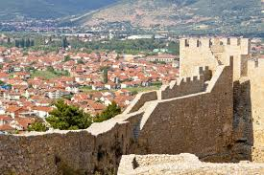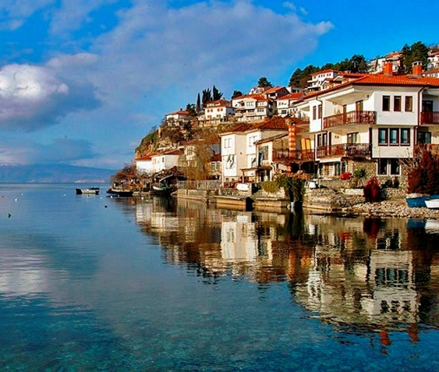

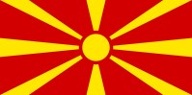
About Macedonia:
The Republic of Macedonia, independent since 1991, is located in the Balkan Peninsula. It borders with Kosovo and Serbia on the North, with Bulgaria on the East, with Greece on the South, and with Albania on the West. Republic of Macedonia is a country at the crossroads of eastern and western civilizations.
Orthodox, Muslims and in smaller numbers Catholics, Protestant and Jews live here together.
The territory is mountainous, with rivers and three natural lakes. The population is estimated around 2 million.

For more information visit: http://www.exploringmacedonia.com/
About Skopje:
Skopje is the capital city of the Republic of Macedonia. It has approximately 500,000 inhabitants. Situated in northern Macedonia, the city is crossed by the river Vardar, the largest river in the country. Skopje is located at 240 amsl and has an area of 1,854 km2. The area of Skopje has been inhabited since 4000 BC: ruins of Neolithic settlements are present in the Kale Fortress.
Most of the ancient buildings of Skopje were built during the Ottoman rule (15 – 19 Century), but nowadays the city as mostly a modern aspect: in 1963, in fact, a massive earthquake destroyed 75% of Skopje. The city center is also characterized by the recent settlement of monument and restoration of buildings in the context of the Skopje 2014 project.
The main attractions in Skopje are the Stone Bridge, the Old Bazar, Mustapha Pasha Mosque, the Kale
Fortress and Sveti Spas Church.
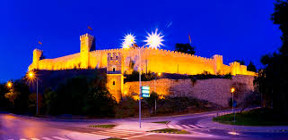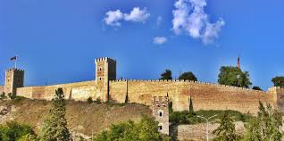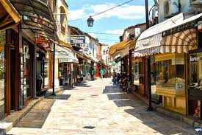

About Kavadarci
The town of Kavadarci is the centre of the Tikves area which got its name by the old settlement formed at the mouth of the River Tikvesica and the River Crna. The numerous objects made of Roman bricks point to the fact that it was an old Roman settlement, where the 17th century records confirmed its existence in the year 1378.
By the end of the 18th century Kavadarci was mentioned under its present name as a part of the Bitola pashalik. Then it had around 2,000 inhabitants. In the period of the Turkish Empire, Kavadarci was permanent administrative centre.
Today Kavadarci is a modern town with the population of 29`000 inhabitants in 9,076 households, which is even 76% of the total population of the area. It is only 100 km away from Skopje.
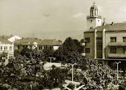
Kavadarci is one of the best known wine growing towns in the Balkans as well as in Europe. The wines are produced in the wine cellars of the plant Tikves and have been awarded many international awards. They are the pride of the Macedonian wine production.

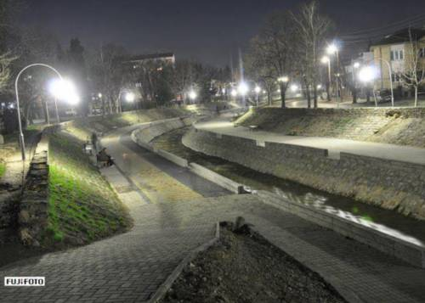

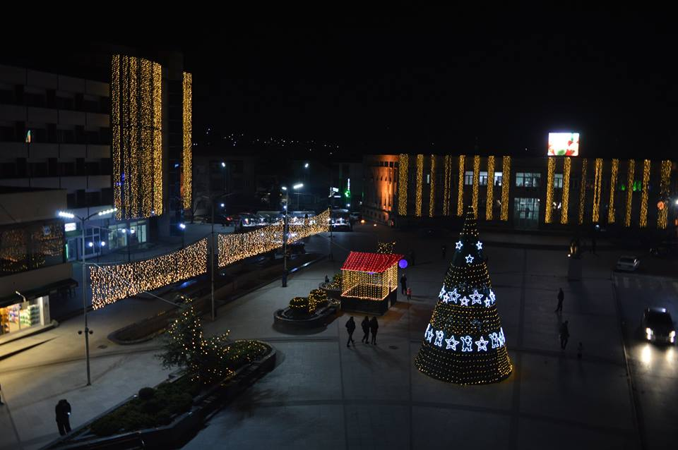

Useful information:
LOCAL TIME:
Macedonian local time is GMT +1.
CURRENCY, ATMs and CREDIT CARDS:
The official currency of Macedonia is the Denar (MKD). Approximately: 1 €=61.50MKD, 1 $ =
46.00MKD. You can find ATMs outside the major banks everywhere in Skopje. All major credit and debit cards are widely accepted. Some examples of local prices:
A coffee: 1-1.5 € A beer: 1.5 € A slice of cake in a patisserie: 1.5 € A piece of bread in a bakery: 0.5 €
ELECTRICITY SUPPLY:
The electricity supply in Macedonia is 220 volts, a.c. 50 Hz. Sockets are generally CEE 7/7. Hotels generally provide with adaptors upon request.
SMOKING:
Smoking is not allowed in all indoor public places.
OPENING HOURS:
Shops normally open around 09:00 and close around 20:00.

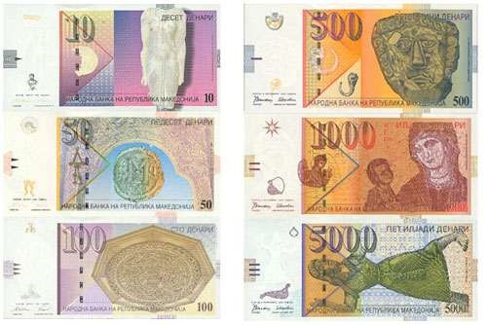

About SEGA and INFO SEGA:

Coalition of youth organization SEGA
Mission:
The Coalition of youth organizations SEGA works on developing and implementing youth policies in Macedonia as well as connecting and strengthening young people to improve their overall state.
Vision:
SEGA is a sustainable and developed youth organization active at the local, regional and national level, a long-term and serious partner in the implementation of youth programmes along with young people, NGOs, state institutions and the business sector.
Our work has led to an improved overall state of youth, their inclusion in decision-making processes and their use of applicable laws.
Our success is recognized in the promotion of the young people as a resource in the society, ready to answer new challenges. Coalition of youth organizations SEGA in 2010 opened the first Youth
INFO Center in Prilep, and in 2015 opened the Youth INFO Center in Kavadarci: INFORMATION AND COUNSELING INFO CENTER INFO SEGA

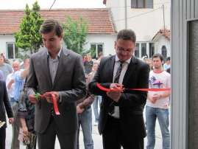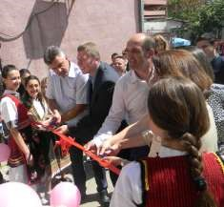
Opening of the first INFO Center in Prilep Opening of the INFO Center in Kavadarci

Youth information and counseling center INFO SEGA Prilep and Kavadarci:

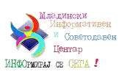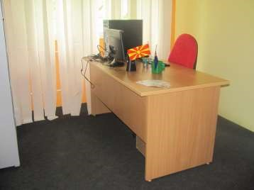
Activities of EVS volunteers at Information and Counseling Center INFOSEGA:
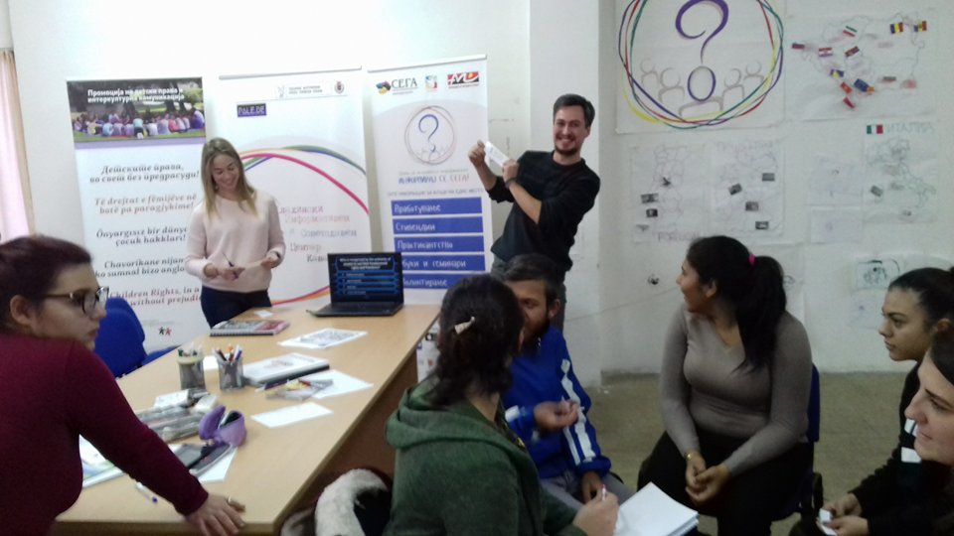
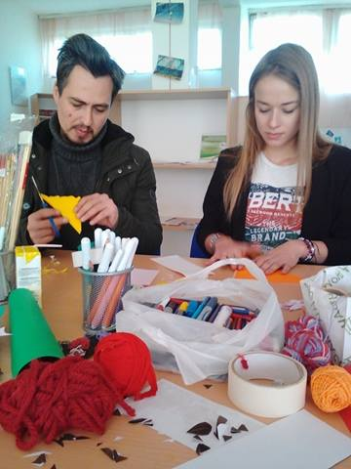
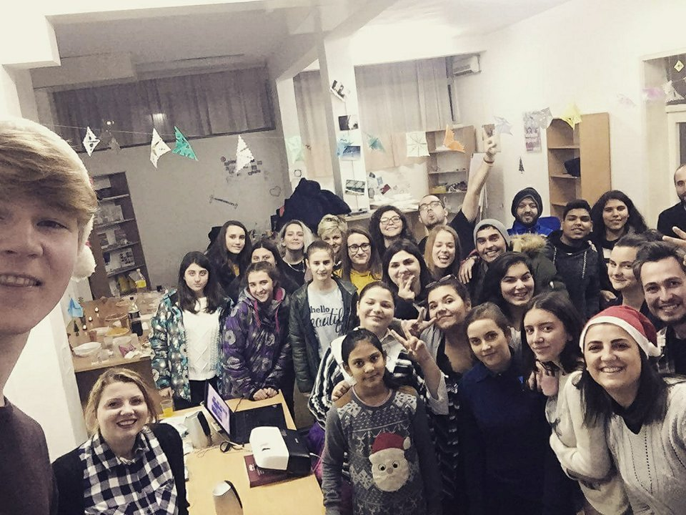

Detail description of the activities in the project “Youth Information Now“

Youth Information Now
EVS activity period: February 2019 – July 2019 (arrival date can be flexible)
EVS duration period: 6 months

Promotion of the importance of using youth information tools and services (online and offline). This will include activities like info days and promotions in the city center and local high schools in Kavadarci. These activities will be implemented for larger number of young people to be introduced with the work of the YIC INFO SEGA Kavadarci and to be able to use its services at local level.

Providing of accurate, up to date and reliable information for young people (culture, volunteering, education, employment, scholarships, trainings, seminars, etc).
Searching for this kind of online information (with given previous directions by the staff of INFO SEGA) and uploading the information on the web site of INFO SEGA (www.infosega.org.mk), also writing and translation of different articles and uploading them on the web site.

Implementation of Creative workshop with children and young people.
The volunteers will organize Summer creative school for children in YIC Kavadarci during summer time (june-august) including workshops based on creativity. It can be origami workshops - a fun and challenging activity (origami helps developing eyehand coordination, memory skills and math’s concepts), craft workshops, jewelry workshop, drawing workshops etc. These workshops will be also done in primary and high schools for some special occasions and holidays like Christmas, Women’s Day, Eastern etc. These workshops are important because they encourage creativity and personal abilities. Group age: 9 – 13 years old.

Implementing different activities for the National Campaign "365 Youth working rights in Macedonia".
The main aim of the campaign is to increase the awareness about the rights and responsibilities of young employees in Macedonia and will be lead by SEGA and Youth Information centers in Prilep and Kavadarci. It consist various activities (offline and online) where the volunteers will be actively involved. The campaign will be implemented from December 2017 - December 2018 and will include youth, young workers, stakeholders, institutions, ministries, syndicates, NGO's and will be implemented on national level.
Increasing the intercultural learning between foreign countries and Macedonian cultures in organizing cultural and creative public events and meetings.
Preparation, organization and implementation of ideas and activities in occasion of some important dates in Macedonia, for example holidays like Easter, Christmas, International Women day , International Youth day etc.– organization or participation on a bazaars and fairs for decorations in some of the primary schools in Kavadarci.

Planning, organizing and implementing intercultural events.
The volunteers will organize one event/week, during one month. They will promote his culture through different activities. Also, the volunteers can contact other volunteers from different countries and locals to organize together the events.

Language coffee.
The purpose of this activity is to meet up with local people, to exchange language skills and cultural insights in a fun and relaxing environment. Having regular meetings with a language exchange partner is a great way to practice and improve a foreign language. The participants will match with the people who speak the language they wish to practice, for exp: English, Spanish, Italian etc. The volunteers will organize the Language Caffee every two weeks. Aspects of languages that they should focus on: speaking: pronunciation, accents; listening: definitions, vocabulary, synonyms; slangs, common ways to express. The volunteers can be creative using some games and activities, especially for the language that people don’t know. For example: hangman, mime, quizzes games etc.
Promotion of EVS programme.
Through this activity the volunteer will promote his/her project and his experience. He/she will talk about what it means to be a volunteer and how can affect your life. They will also prepare different ways to promote Erasmus+ and talk about it. This activity will be very useful for the young generation, especially because most of them don’t know the actual meaning of EVS (what the program includes, what are the conditions to become an EVS volunteer and how can they find projects and organizations that are accredited for sending and hosting EVS volunteers). It can be a perspective for the young people regarding their future.

Initiating and implementing ideas for individual projects.
This activity will include working on an individual project idea, preparing and writing project application (with support and help from the staff of INFO SEGA). With this kind of activities the volunteers will have a chance to strengthen their capacities and skills for developing of their own project ideas and filling of project applications.

Coordinate meetings between the staff of INFO SEGA and Coalition SEGA (once in a month)
Participating and working in the everyday activities of INFO SEGA.

Practical arrangements:

Travel costs from Spain to Macedonia: 275€ both way
Travel costs from Italy to Macedonia: 275€ both way
Travel costs from Turkey to Macedonia: 275€ both way
Pocket money: 60€ per month
Food money: 90€ per month
The volunteers will receive full insurance coverage through EVS Insurance provided by the European Commission. All the insurance documents will be sent to the volunteers by the sending organization.
The volunteer’s enrollment in the insurance program will be completed before the departure of the volunteers to Macedonia.
Republic of Macedonia has free non-visa entrance for EU volunteers. In the three month gray period after his/her arrival; the hosting organization will be responsible for the application process for issuing/extending a permit for temporary residence in the Republic of Macedonia. The process requires gathering and completing many documents and proofs, and all of them should be legally translated by authorities on Macedonian language. Some of the needed documents will be required from the volunteer before his/her arrival. The visa process for Macedonia in EU countries requires volunteers to go back in their countries and receive the visa in person.
Each of the volunteers will have a different mentor who will be in contact with the volunteers and the time when there will be need. The mentors will adapt the volunteers to the new environment and life in Macedonia in general. These persons were chosen to be mentors because of their long experience as volunteers, knowledge of the previous “Youth in action programme”, the new programme Erasmus+, and their experience in intercultural encounters. Mentors and volunteers will have weekly meetings to help the volunteers integrate in local community and to establish contacts with local people and different local organizations.
Twice a week the volunteer will visit Macedonian language courses. We will also encourage the volunteers to start to learn Macedonian before their departure thanks to online website and support such as Memrise for example. The main working language at the office will be English; in this context the selected volunteers are eligible to receive linguistic support in English prior to departure or during the activity through the Online Linguistic Support.

Tickets and bills:
When travelling through Macedonia you should always ask for a special bill called “fiskalna smetka” (on Macedonian) or invoice. We would also like to remind you to keep your boarding pass and all other travel tickets otherwise we cannot approve your travel cost if you travel by plain. Once again,
Please keep all your invoices/receipts related to your travel!
Weather in Macedonia:
The weather in Macedonia in May and June is from 25 - 35 Celsius degrees. It also might be rainy.

Accommodation:
The accommodation of the volunteers will be ensured by the hosting organization. The volunteers will share flat with separate bed rooms with all basic needs covered according the standards of living in Macedonia. The volunteer’s accommodation will be near the mentors who are responsible for their learning processes, accommodation and cohesion. The volunteers will have 24 hours full support. In case of dealing with conflicts, the mentors will act as mediators and seriously will find the solution for the problem and conflicts.
Each of the three volunteers will have a different mentor who will be in contact with them and the time when will be in need. The mentors will orientate the volunteers to the new environment and the life in Macedonia in general and will speak with the volunteers about his/her learning objectives. The mentors will help the volunteers to integrate in the local community and to establish contacts with local people and different local organizations.

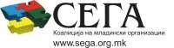
Contacts:
Zoran Ilieski
e-mail: zorani@sega.org.mk mobile phone number: +38978470400

Georgina Veljanoska
e-mail: georgina@sega.org.mk mobile phone number: +38977935544

Elena Lazova
e-mail: elena@infosega.org.mk mobile phone number:+38978281471

Marice Treneska
email: marice@infosega.org.mk mobile phone number: +38970308746

More information about the host organization on the following official web sites:

- www.sega.org.mk
- www.infosega.org.mk
More information about successful EVS stories on the following link: http://kavadarci.infosega.org.mk/evs-news.

