Info Pack
Dear partners and friends,
we are really happy to inform you that our Training Course “Connecting through Science II: Green Europe” was approved by DZS (www.dzs.cz/eu) and supported by the Erasmus+: Youth grant (http://www.naerasmusplus.cz/).
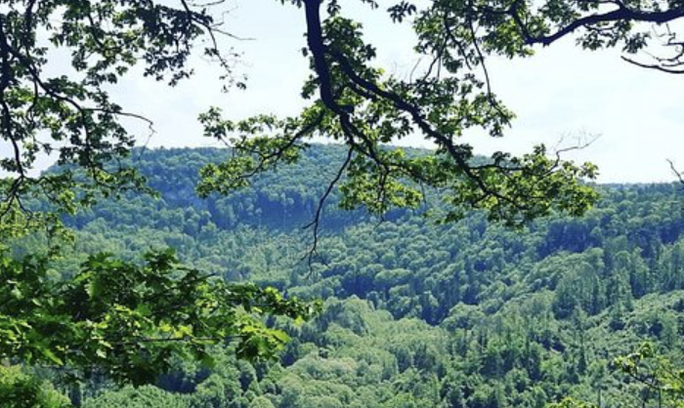
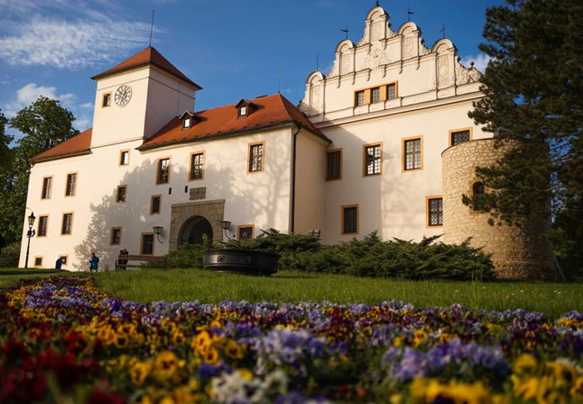
This training course will take place in Blansko, Czech Republic in the week of 29th July to 6th August 2025. Blansko is beautiful for its picturesque location at the gateway to the Moravian Karst, offering lush forests and rich history.

This training course will host 28 youth workers working directly with youth from five different countries: Czech Republic, Greece, Hungary, Ireland, and Italy. These youth workers have a strong power for supporting the youth they work with.
Now you are reading the InfoPack that will help you with the basic information you will need during your stay in the Czech Republic.
If you have been chosen by your organization to participate in this project, please submit the Application form through Google Forms no later than 31st May 2025.
Please, be aware of the fact that it is compulsory for all participants to have travel health insurance covering the whole duration of your stay in the Czech Republic, including the days of your arrival and departure. Please also bring your EHIC card with you.
If you have any special needs (allergies, diets, disabilities, disadvantages, etc.) state them clearly in the Application Form.
Please, wait for the approval of your tickets by us before buying them! We will not be able to refund any expenses made before our approval of your tickets!
We kindly ask you to choose the most economical and eco-friendly way of transport (e.g. student fares, low cost airlines, 2nd class trains, etc.). Also be aware of your travel cost reimbursement budget. We can only reimburse the travel cost up to the limit designed for your country. We will also reimburse only those tickets that will show the currency, dates of your travel, places you are traveling from/to and your name (or number of passengers). It is important to keep all your tickets (also from your local buses and trains).

The description of this training course:
The training course “Connecting through Science II: Green Europe” is addressing the pressing issues of the climate crises, carbon footprint, and the promotion of sustainable practices, with a specific emphasis on renewable energy sources, energy efficiency, forests, agriculture, and waste management. This initiative envisions fostering a greater understanding of these critical subjects among youth workers, empowering them to contribute to environmental sustainability so this further gets translated into their daily work with youth. This is going to be the main goal of the implementation of our training course. During our mobility, the youth workers will be provided invaluable opportunities for professional development through non-formal and informal learning experiences.

The emphasis will be on practical skills that can be directly applied in their youth work practices. This training course is fully aligned with Erasmus+ Programme’s horizontal priority of “Environment and fight against climate change.”

Furthermore, this training course is in alignment with the European’s Commission priority of “The European Green Deal” which fully recognized that climate change and environmental degradation are an existential threat to Europe and the world.

MISSION STATEMENT: Empowering youth workers to become catalysts for positive environmental change through dynamic learning experiences, cross-cultural collaboration, and sustainable practices.

VISION STATEMENT: To foster a network of environmentally conscious youth workers who lead by example, inspire their communities, and drive global action towards a sustainable and climate-neutral future.

COMMITMENT STATEMENT: We are committed to equipping youth worker with the knowledge, skills, and resources necessary to promote environmental sustainability within their communities and youth work activities. Our project aims to create a lasting impact by cultivating a sense of environmental stewardship and fostering cross-cultural cooperation among participants.

The needs of a hosting and sending organizations have been a guideline for the main OBJECTIVES of this training course:

- Enhance non-formal and informal learning: provide a dynamic learning environment that emphasizes non-formal and informal learning methods, ensuring that participants gain practical insights and skills that can be applied in their youth work practices.

- Encourage cross-cultural collaboration: facilitate opportunities for cross-cultural collaboration and knowledge exchange among participants, enabling the sharing of best practices and diverse perspectives on environmental issues among youth workers, organizations, communities, societies, and countries.

- Promote sustainable practices and green initiatives: equip youth workers with practical skills and strategies to promote and implement sustainable practices in their communities and youth work activities. Provide participants with tools and knowledge to design and implement green initiatives and projects, contributing to the reduction of carbon footprints and the promotion of environmentally friendly practices.

- Connect with Nature: facilitate experiences that allow participants to directly engage with natural environments. Develop a heightened sense of environmental consciousness by encouraging observation, appreciation, and understanding of the ecosystems around them. Provide dedicated time for participants to reflect on their personal connection with nature.

Country list and maximum travels costs
Country | Organisation | Count people | Travel cost per person (€) | Travel cost per group (€)
Czech Republic | Evropské centrum mládeže Břeclav / European Youth Centre Břeclav z. s. | 8 | €28 | €224
Greece | Filoxenia Diapolitismiki Perivallontiki Organosi | 5 | €309 | €1545
Hungary | Én Kint Egyesület a Békéért és Fejlődésért | 5 | €285 | €1425
Ireland | Waterford and South Tipperary Community Youth Service Ltd | 5 | €309 | €1545
Italy | STUDIO PROGETTO SOCIETA COOPERATIVASOCIALE | 5 | €309 | €1545

Accommodation
You will be accommodated in Vyhlídka Blansko in rooms for 3-4 persons.
The arrival day is Tuesday 29th July and departure day Wednesday 6th August 2025.

The contact details of the venue are the following:
Rekreační zařízení Vyhlídka, Češkovice 158, 678 01, Blansko, Czech Republic
Telephone: +420 516 415 080 Cell phone: +420 733 745 329, +420 734 231 886
GPS: 49°22´42.687´´N, 16°40´35.046´´E

Please, see the Travel Guide for your travel options at the end of this document.

What to prepare/bring and other information
There will be an “intercultural evening” during the project. For this, please bring traditional meals, candies, drinks, flag or other national symbols and some leaflets about your country and region.
August in the Czech Republic is usually warm, with temperatures around 20-30 degrees Celsius. Mornings can be mild, and days are often sunny, though occasional clouds or summer storms may occur. The weather can vary, so please check the forecast for Blansko before packing.
Most of the course will be held indoors, but if the weather is pleasant, we will do some activities outdoors. We recommend bringing comfortable clothing for both indoor and outdoor activities, along with sturdy shoes for walking. Indoor shoes or slippers are also suggested.
Take the medication you take regularly with you (you know yourself the best so take with you painkillers, antihistamines, etc.)

Travel Guide
Your first task connected with this training course will be to get to Blansko where our project takes place.
If you are traveling by plane, you can arrive to:
- Prague Airport (Czech Republic),
- Vienna Airport (Austria)
- or Bratislava Airport (Slovakia).
From these airports it is recommended to travel to Brno by buses or trains and then to Blansko by train or bus. While deciding, please consider the price first. You can find your bus/train connections on this journey planner website (you can also buy your tickets there): https://idos.cz/en/vlakyautobusy/spojeni/
If you’d like to travel from the airport by bus, it is recommended to use Student Agency (yellow) buses. The platform of Student Agency buses is right in front of the Arrival hall of Vienna and Prague Airport (Picture 1).
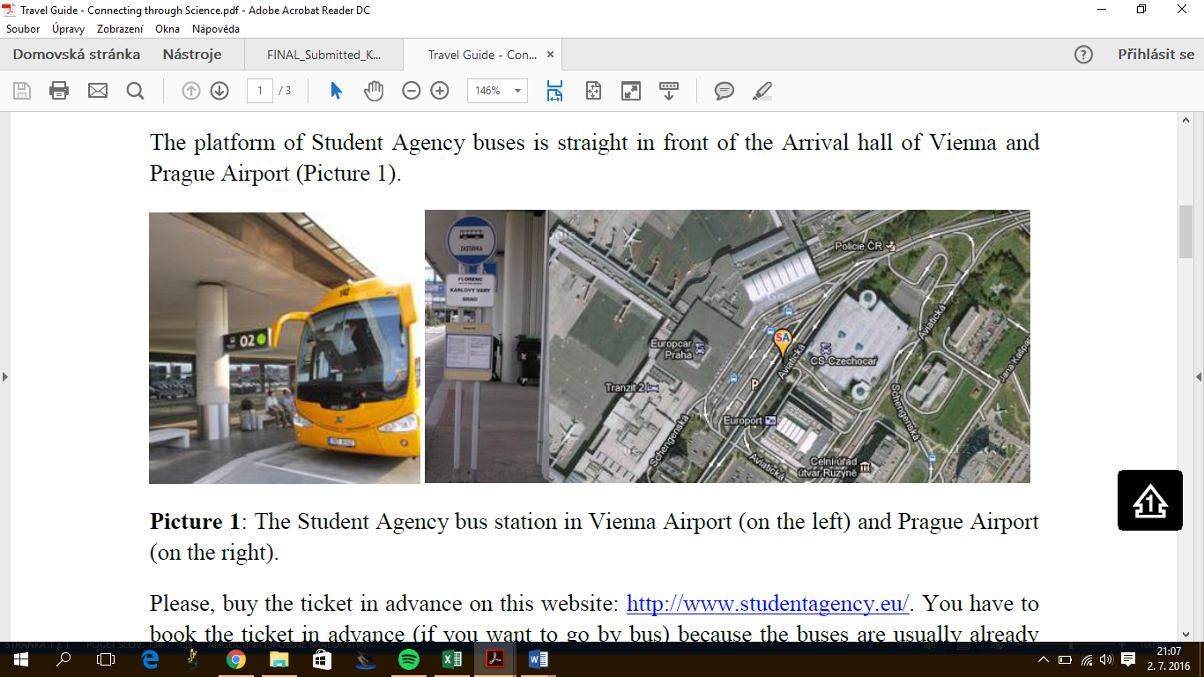
Picture 1: The Student Agency bus station in Vienna Airport (on the left) and Prague Airport (on the right).
Please, buy the ticket in advance on this website: https://www.studentagency.eu/en/. You have to book the tickets in advance (if you want to go by bus) because the buses are usually already completely full a couple of days before their departure.
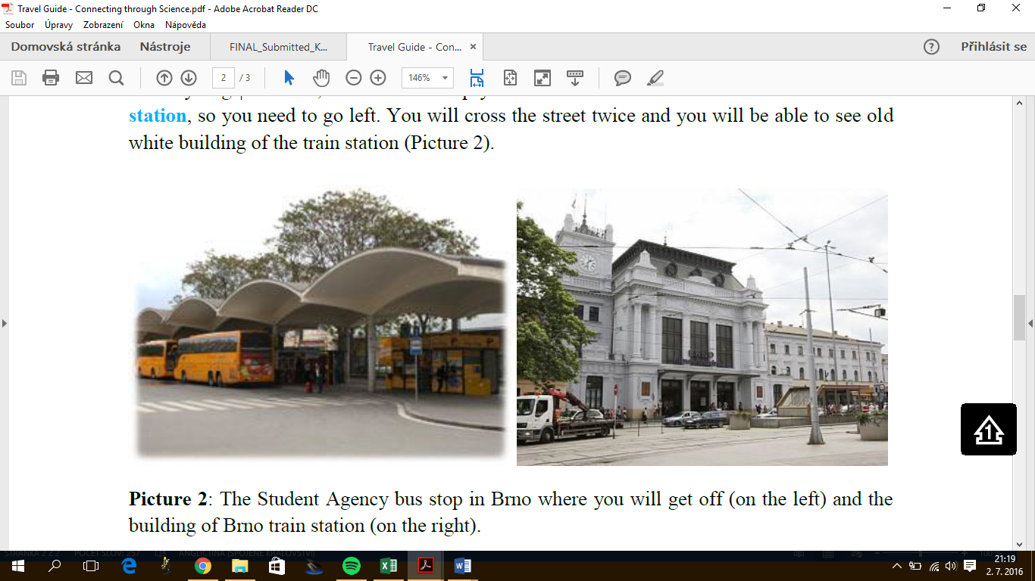
When your bus arrives to Brno, it will drop you off about 300 meters from Brno Main Train Station. You will cross the street twice to be able to see the old while building of the train station (Picture 2).
Picture 2: The Student Agency stop in Brno where you will get off (on the left) and the building of Brno Train Station (on the right).
Online at www.idos.cz (or at the Main Train Station in Brno) you can buy a single ticket to Blansko.
How to get to the accommodation from Blansko:
By bus from Blansko: it is most convenient to use the services of the city line Češkovice – Sever, which will take you almost to “Vyhlídka – Češkovice” stop. Another option is the bus: #727 233 Blansko – Sloup – Ludíkov – Benešov. But only a few connections go to the Obůrka stop, which is a village located about 1km (10 minutes walk) above Vyhlídka.
On foot from Blansko: you can also walk from Blansko to our accommodation (approx. 3km) but please bear in mind that almost the entire walk will be uphill.
You can check the train/bus times (and buy tickets online) here: www.idos.cz
In the Czech Republic it is possible to pay for transportation on local buses by card or cash (Czech crowns).
1 EUR = ± 25 CZK

If you need any help or you have any questions, do not be hesitate to contact us! ☺

Eva: eycb.info@gmail.com | WhatsApp: +1 562 832 0287
Jana: info@eycb.eu | WhatsApp: +44 777 0528 238

See you soon in Blansko! ☺
Your EYCB team

Funded by the European Union. Views and opinions expressed are however those of the author(s) only and do not necessarily reflect those of the European Union or the Czech National Agency for International Education and Research (DZS). Neither the European Union nor DZS can be held responsible for them.

